# OMH CAIRS

## **Admissions and Discharges**

**Tools needed:**

**Elizabeth Coffie, MBA**

**Office of Mental Health**

(518) 474-9458 | Fax (518) 486-5587|

[Elizabeth.Coffie@omh.ny.gov](mailto:Elizabeth.Coffie@omh.ny.gov)

[www.omh.ny.gov](http://www.omh.ny.gov/)

* AWARDS access https://depaul.footholdtechnology.com
* OMH/CAIRS access with two log ins (LOD and DCS) https://mhprovider.omh.ny.gov/websalute/legal.asp
* CAIRS Token log in and software
* AWARDS OMH Program Reference

**Log into AWARDS:**

In AWARDS you will receive bi-weekly emails with admission and discharge information. These emails have lists that run concurrently with the newest admission/discharge information.

Before you start, you will need to compare the new list with the previous list to know where to start with for the current week.

Use the CAIRS- Updates Tracking worksheet to keep alist of LOD and DCS admission and dicharges. DePaul\DePaul IT - App Enterprise-OMH\OMH\CAIRS\CAIRS - Updates Tracking.xlsx

We need to process any new Admission and/or Discharge. Use the VLOOKUP sheet to compare the new list to the processed list. This will catch residents with backdated Admission and/or Discharges.

1. Copy the entire list into this sheet. Use a VLOOKUP to see if they are on the previous sheet. (Used to catch a backdated admission.)

2. The VLOOKUP will look for the resident by name and return the Admission or Discharge date if they are on the sheet already. #N/A if they are not on the sheet.

3. The Admission or Discharge dates will match for current Admissions or Discharges. You want all current period records.

4. A resident can be on the list twice (Admission and then Discharge). The VLOOKLUP will return an old date. They need to be processed this period.

5. Copy over all new Admissions and Discharges Name. (#N/A's and any that were on the list with an old date but now have a new date.) Copy 4 Columns, Name Program Admission/Discharge and Date. Do not copy the formula(VLookup)

6. The list will be overwritten the next time. (leaving the VLOOKUP formula) so it can be used the next time.



Admission was processed on 2/6. Discharge needs to be processed.

#N/A’s need to be processed in CAIRS.

Those with dates have been processed previous time.

Search the client in AWARDS. You will need their admission and discharge information to complete this process.

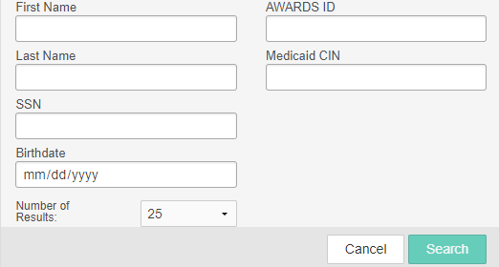

**Don’t do in CAIRS**

DDS emails

Hopelink

Reintegration Support

Crisis Housing Emergency Housing

REP Payee Workguide

FDS- Apple Blossom, Boxcar, Lock 7

Using EDGE - Log into the OMH website using one of your two log ins (LOD amd DCS)

You must use a token with your user ID to gain access. Then select CAIRS from the menu provided.

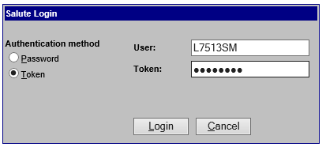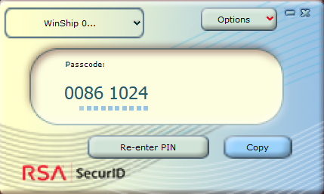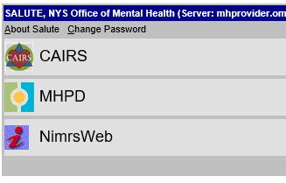

You must open CAIRS in Internet ExplorerCapability Mode. You must do this every 30 days.

**To begin OMH CAIR Admissions/Discharges please refer to the OMH CAIRS Admissions/Discharges Flow Chart.**

## **CAIRS Client Search**

**Data Entry -> Client Search**

**This is where you will search each client to establish if they have information within the CAIRS platform.**

When searching in CAIRS for a client you can use any combination of the following:

* Name/ Partial Name (First and Last)
* Medicaid number
* Social Security number
* Date of Birth

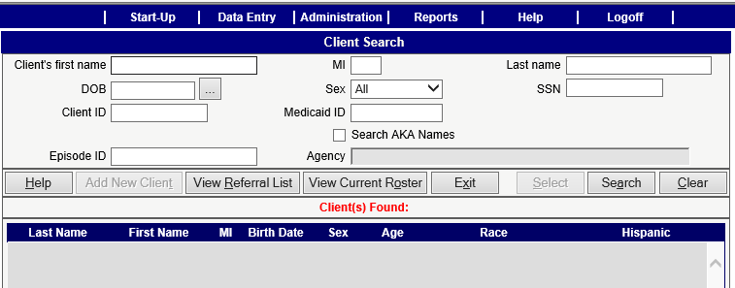

Once you have located your client, refer to the **Creating a New Episode in CAIRS** document.

**NOTE:** If you perform a search and you cannot locate a client you must add them into CAIRS before you can create a new episode for an admission. Refer to the **Adding a New Client in CAIRS document**.

**To Discharge:** If you are searching a client for a discharge see the **Discharging a Client in CAIRS document**

## **Creating a New Episode in CAIRS**

**(For admissions)**

If you search a client for an admission and you find they are already in CAIRS, double click on the search results.

You will then see the Client Episode Information screen:

* Verify the client information is accurate (you may edit client information by clicking on the blue hyperlink if needed)
* Select “Create New Episode”

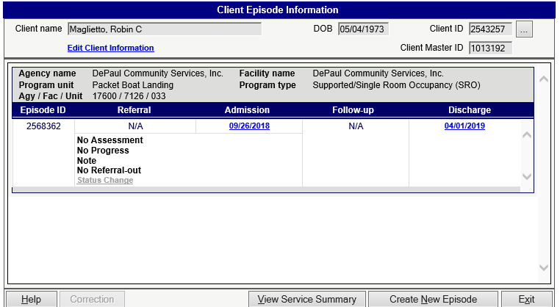

**Program Selection:**

Choose the program the client is being admitted to. You may need the AWARDS OMH Program Reference

(document) to cross reference the OMH name and DePaul name of the program.

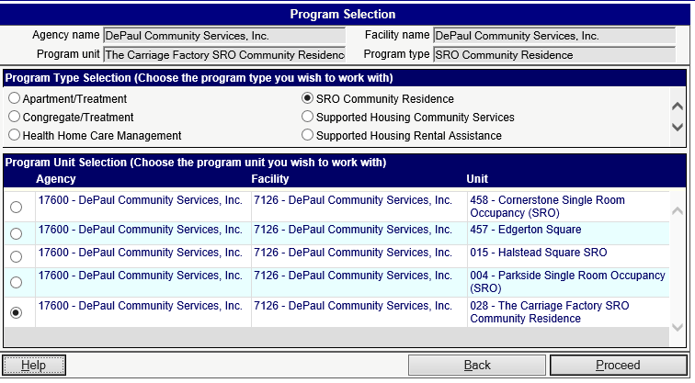

Refer to the **Adult Admission/Placement Form document**

## **Adding a New Client in CAIRS**

If you have seached for a client and did not find them, you will need to select “**Add a New Client”** from the client search screen. The New Client Information form will appear.

Using information from Awards complete the following fields:

* Clients First and Last Name
* Date of Birth
* Sex
* Medicaid number (if they have one )
* Social Security number

Then select the clients race and Hispanic/Latino. “Save”.

Once you’ve saved this form you will get a message asking you to confirm you want to add the new client. The sceen will flicker.



Then select “Create New Episode” at the bottom of the page.

**Program Selection:**

Choose the program the client is being admitted to. You may need the AWARDS OMH Program Reference

(document) to cross reference the OMH name and DePaul name of the program.



You will then see the Create New Episode screen:

* Verify the client and program information is accurate.
* Select the word “New” under admission

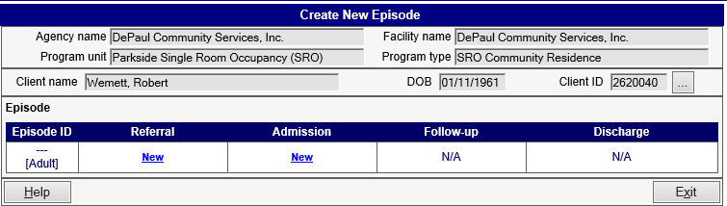

After you select “New” admission : **See Adult Admission/Placement form directions.**

## **Adult Admission/Placement Form**

Once the client’s program has been selected, you will then proceed to the Adult Admission/Placement form.

Verify the client information at the top of the page is accurate. Use the Admission notes in AWARDS for the following:

* Admission Date
* Primary Language (if known)
* Pre-admission living situation
* Medicaid
* At the bottom of the page you want to answer the questions based on the admission notes from AWARDS.

**NOTE:** Search the Admission Notes for words, Homeless and MRT

Then **SAVE** and **EXIT** the form.

You then return to the Client Episode Information screen. Verify the admission is for the correct program, client and the admission date are showing. The select “Exit” and you return to the search screen.

## **Discharging a Client in CAIRS**

Once you have searched your client, double click on your search results. You will be taken to the Client Episode Information screen.

* Review the client information and program admission dates are correct.
* Click “New” under discharge this will take you to the Adult Discharge- Demographics screen.

On the Adult Discharge- Demographics screen there are two tabs on the page that need to be completed. **Discharge and Reason**

On the Discharge tab complete the following:

* Discharge date
* Select a Post discharge living situation (found on the discharge in AWARDS)
* Check the box that says “check here to confirm the above information is complete” (at the bottom in red)
* Click on the Reason tab

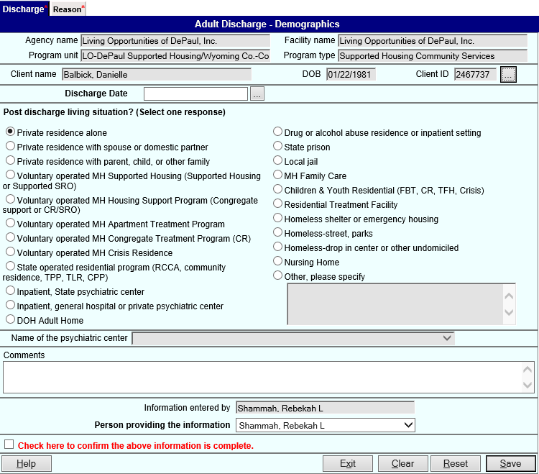

On the **Reason** tab complete the following:

In AWARDS read the Consumer History Report for discharge reason.

* Select the discharge reason
* Check the box next to “check here to confirm the above information is complete” (at the bottom in red)

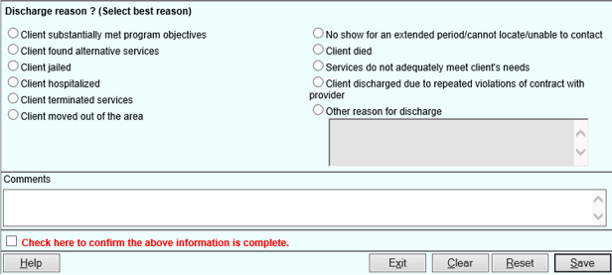

Once both tabs are completed you may select “Save” at the bottom of the page. Then select “Exit”.

You then return to the Client Episode Information screen. Verify the discharge is for the correct program, client and the discharge date is showing. The select “Exit” and you return to the search screen.

Mark it as Done on the CAIRS - Update Tracking sheet.

## **Add a Program to CAIRS**

Notes:

Email thread dated 10/18 from Kate Rider confirming which programs are no longer going to be entered in CAIRS in 2023. Rebekah and I have an appointment on ½ to do this.



OMH has determined that they only want actual “beds” to be entered into CAIRS so moving forward for 2023 you will no longer have to enter data into CAIRS for the HUD beds.

Voluntary Operated MH Supported Housing (Supported Housing or Supported SRO) LO DePaul SH/Erie County COC III - Comm Svcs

Voluntary Operated MH Supported Housing (Supported Housing or Supported SRO) LO-DePaul SH/Erie County COC I - Comm. Svcs-Comm.Svcs